Name Date
Social Studies 7, Period , 2nd Quarter Mr. Piraino

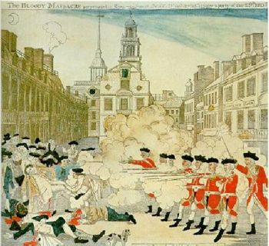

“The Boston Massacre”
By Jay-P

The colonists were threatening the tax collectors
So the English troops were sent to be their protectors
But the English troops the colonists would resent
Because they hated who the troops would represent
They’d make fun of their uniforms ‘cause they were whack
Since their uniforms were red, they screamed “Lobsterbacks!”
The troops and the colonists would always fight
But it all came to a climax on one terrible night
It was March 5th, 1-7-7-0
A fight took place but there would be no hero
Loud bells rang and a large mob grew
Around one British soldier who very well knew
That he was outnumbered so he called for help
The soldiers came to his aid when they heard his yelp
The mob got crazy, started throwing stuff
Like ice, sticks, and oyster shells, man, it was rough
And the soldiers were surrounded, there was nowhere to run
The bullets started flying from each gun
Crispus Attucks, a black sailor, he was shot
Other poor men would share his lot
And the end result was what the colonists feared
Five colonists were dead when the smoke cleared

It was a massacre on King Street in Boston
Look at all the hate and lives it was costin’

8 soldiers were arrested for this tragedy
“It was self-defense, we’re not guilty!”
They needed a lawyer, said the law
They hired John Adams, a colonist who saw
That every man should have a fair trial
When others thought that it was out of style
The colonists thought that he was a traitor
“They have a right to a lawyer, so don’t be a hater”
Not guilty was the verdict for six of the men
The other two were guilty of manslaughter but then
John Adams said “They get Benefit of Clergy”
They read from the Bible to prove they were worthy
Of only having to get a brand on their thumb
No death penalty for them, that angered some
And the memory of March 5th would last for years
The colonists vowed revenge for all of their tears

It was a massacre on King Street in Boston
Look at all the hate and lives it was costin’

1. Describe the relationship between the British soldiers and the colonists before the Boston Massacre.

2. What name did the colonists call the soldiers?

3. What was the date of the Boston Massacre?
4. Which street did the Boston Massacre happen on?
5. What caused the Boston Massacre?

6. How many colonists were dead at the end of the Boston Massacre?
7. How many soldiers were arrested for the Boston Massacre?
8. Under “Benefit of Clergy”, what did the two soldiers have to do to avoid the death penalty?

