Name Date
American History 7 Mr. Piraino

We Will Survive

A parody of Donna Summers’ “I Will Survive”
By Mr. Piraino, The King of the Social Studies Disco

First we were afraid, we were petrified
Kept thinking how we couldn’t live without you by our side
But then we spent so many nights thinking how you did us wrong
But we grew strong and we learned how to get along
And now you’re back from Great Britain
Have you forgotten ‘bout the words that Thomas Jefferson’s written?
We tried to close off all our trade; we tried to make you leave the West
But you’re coming back for more; you want to put us to the test
Get back and go back on your boats
Don’t turn around now, on the ocean you will float
Weren’t you the ones that tried to hurt us with your guns?
Did you think we’d crumble, put our hands up, and run?

Oh no, not us
We will survive!
Oh, as long as we know we are right
We’ll continue to fight
We’ve got all our life to live
We’ve got this freedom to give
We will survive!
We will survive!
Hey, hey

1. Which country’s point of view is this song being sung from?

2. Which country is the singer singing to?

3. Before the War of 1812, how had Great Britain done us “wrong?”

4. Which document is the song referring to in the line “Did you forget about the words that Thomas Jefferson’s written?”

5. In one sentence, describe what the song is about.

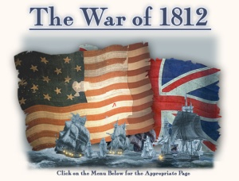
1. Which country’s point of view is this song being sung from? U.S.

2. Which country is the singer singing to? Great Britain

3. Before the War of 1812, how had Great Britain done us “wrong?” Impressments and giving guns to the Native Americans

4. Which document is the song referring to in the line “Did you forget about the words that Thomas Jefferson’s written?” The Declaration of Independence

5. In one sentence, describe what the song is about.

